Annual session 2018
4 to 8 June 2018, New York

Item 15 of the provisional agenda
Internal audit and oversight

Activity report for 2017 of the Internal Audit and Investigations Group of the United Nations Office for Project Services

Summary
The Director of the Internal Audit and Investigations Group of the United Nations Office for Project Services hereby submits to the Executive Board this activity report on internal audit and investigation services for the year ended 31 December 2017. The response of UNOPS management to this report is presented separately, as per Executive Board decision 2006/13.
Elements of a decision
The Executive Board may wish to:
- take note of the annual report of the Internal Audit and Investigations Group for 2017 and the management response thereto;
- take note of the progress made in implementation of audit recommendations;
- take note of the opinion, based on the scope of work undertaken, on the adequacy and effectiveness of the organization’s framework of governance, risk management and control (in line with Executive Board decision 2015/13); and
- take note of the annual report of the Audit Advisory Committee for 2017 (in line with Executive Board decision 2008/37).

Contents

Chapter |  |  | Page
- Executive summary 3
II. Introduction 4
III. Role and functions of the Internal Audit and Investigations Group 4
IV. Approved annual internal audit workplan for 2017 5
V. Highlights of 2017 audit activities 6
VI. UNOPS accountability framework 12
VII. Disclosure of internal audit reports 13
VIII. Advisory services 13
IX. Investigations 13
X. Summary of follow-up of internal audit recommendations 18
XI. Operational issues 19
XII. Audit Advisory Committee 23

Annexes (available on the Executive Board website)
- Unresolved audit recommendations issued more than 18 months before 31 December 2017
- Titles of all internal audit reports issued during the year 2017
- Audit Advisory Committee – annual report 2017
- Reports issued by the Internal Audit and Investigations Group in 2017 that resulted in findings of misconduct
- Criteria supporting the audit opinion of the Internal Audit and Investigations Group
- Key areas for improvement identified in audit reports

Executive summary
- Audit opinion. In the opinion of the Internal Audit and Investigations Group (IAIG), based on the scope of audit and investigations work undertaken in 2017, the adequacy and effectiveness of UNOPS governance, risk management and control were partially satisfactory (major improvement needed), which means that they were generally established and functioning but needed major improvement. Management has taken immediate and commendable action to address the audit opinion, including efforts to strengthen oversight at the local, regional and corporate levels, partly evidenced by a high recommendation implementation rate in 2017.
- Output. In 2017, six auditors delivered 14 internal audit reports (two more than the 12 initially planned) and 31 project audit reports (four more than in 2016). The average time taken for internal audit reports to be issued was within the key performance indicator target of 90 days. The investigations team handled 111 complaints, from which 59 cases were opened (highest IAIG caseload since inception). All cases were closed within 12 months of opening. The group also substantiated $268,507 in fraud, and referred 15 vendors for sanctioning. Audit also referred six issues to investigations for review.
- Delivering better for less. In 2016, the Joint Inspection Unit (JIU) found IAIG has the lowest cost-per-audit-completed in the United Nations system. In 2017, IAIG increased its audit engagement output to 45 engagements (37 in 2016) plus four new data analytics engagements, while keeping overall costs constant. Continued delivery of better assurance for less cost is a key priority for IAIG.
- The IAIG role in UNOPS strategy. IAIG is the third line of defence in UNOPS governance, risk and compliance framework, providing independent assurance of how the organization manages its activities. The group also investigates fraud and misconduct, and provides independent advice to management.
- Supporting strategic initiatives. IAIG conducted four strategic engagements in 2017: a cyber-security assessment of UNOPS procurement platform (e-sourcing and United Nations Web Buy Plus), a vulnerability assessment of critical applications and infrastructure, a review of the Global Shared Services Centre and an assessment of the implementation of recommendations of cyber security, cyber vulnerability and enterprise risk planning fraud risk assessments.
- Innovation. In 2017, IAIG refined its data analytics and continuous auditing algorithms, adding new tests such as duplicate payments, sanctioned vendors, Benford’s Law and AccuityTM matching, and designing dynamic visuals for ease of use by practitioners. The group identified $311,188 in payments to sanctioned vendors, $30,144 in duplicate payments and closed over 16,000 inactive or duplicated vendor accounts. The group’s vision is to empower the first and second lines of defence to conduct this type of analysis proactively.
- Quality. In 2017, IAIG received the highest rating offered by the Institute of Internal Auditors in an external quality assessment conducted by PricewaterhouseCoopers. IAIG was assessed to “generally conform” to the Institute of Internal Auditors’ International Standards for the Professional Practice of Internal Auditing.
- Teamwork. The IAIG team of professionals was further strengthened in 2017, through the addition of two audit and two investigations professionals.
- Collaboration with partners. UNOPS strengthened its relationships with oversight partners by becoming the first United Nations organization to establish an anti-fraud cooperation memorandum of understanding with the Swedish International Development Cooperation Agency.

Introduction
- The Internal Audit and Investigations Group is pleased to provide the Executive Board with the annual report on UNOPS internal audit and investigation activities for the year ended 31 December 2017.
- This report provides the IAIG opinion, based on the scope of work undertaken, and on the adequacy and effectiveness of UNOPS governance, risk management and control processes (Executive Board decision 2015/13).
- The IAIG Director reports to the Executive Director of UNOPS, supporting her accountability function. IAIG provides assurance, offers advice, recommends improvements and enhances the risk management, control and governance systems of the organization. The group also promotes accountability by conducting investigations into reports of violations of applicable rules, regulations and administrative or policy directives.
- IAIG continued to interact with the UNOPS Audit Advisory Committee in 2017. In accordance with Executive Board decision 2008/37, the annual report of the Audit Advisory Committee for 2017 is attached as annex three to this report.

Role and functions of the Internal Audit and Investigations Group
- The mandate, functions and standards for internal audit and investigations within UNOPS are approved by the Executive Director as executive office directive EOD.ED.2017.04, effective March 2017. Per regulations 6.01, IAIG:
Shall conduct independent, objective assurance and advisory activities in conformity with the International Standards for the Professional Practice of Internal Auditing. It shall evaluate and contribute to the improvement of governance, risk management and control processes, and report thereon. It shall exercise operational independence in the performance of its duties.
- The international internal auditing standards require that the Chief Audit Executive must report to a level within the organization that allows the internal audit activity to fulfil its responsibilities and must confirm to the Executive Board, at least annually, the organizational independence of the internal audit activity. IAIG hereby confirms its organizational independence. In 2017, IAIG was free from interference in determining its audit scope, performing its work and communicating its results.
- Per regulation 6.02, in addition to providing internal audit services to UNOPS, IAIG is “responsible for assessing and investigating allegations of fraud and corruption committed by UNOPS personnel or committed by others to the detriment of UNOPS”.
- The mandate, scope, responsibility, accountability and standards of IAIG are further defined in the following: the Internal Audit Charter approved by the Executive Director and issued as operational directive OD.IAIG.2018.02, revised and effective March 2018; and executive office instruction EOI.ED.2018.01, “Organisational Structure”.
- Further, under the UNOPS governance, risk and compliance framework, IAIG assumes the role as third line of defence.

Approved annual internal audit workplan for 2017
- The primary aim of the 2017 workplan was to evaluate and improve the effectiveness of risk management, control and governance processes, and to provide the Executive Director with the assurance that internal controls and procedures are functioning as intended.
- Risk-based internal audit plan
- In preparing its 2017 workplan, IAIG has continued to ensure consistency between audit priorities and the goals of UNOPS management. IAIG gathered data from a variety of internal sources and consulted existing components of the risk management system mandated in UNOPS financial regulation 4.01 and financial rules 104.01 and 104.02 to perform this assessment.
- The 2017 audit workplan, based on the audit risk assessment, acknowledged the geographical diversity of UNOPS operations worldwide and included both internal field office audits and performance audits.
- Progress on implementation of annual workplan
- In 2017, six auditors delivered 14 internal audit reports (two more than the 12 initially planned) and 31 project audit reports (four more than in 2016). The average time taken for reports to be issued was within the key performance indicator target of 90 days. All of the internal audits planned for 2017 were completed and the final reports were issued during the year (see table 1).
Table 1. Status of implementation of the workplan as at 31 December 2017
 | IAIG internal audits | Project audits | Total | Total in 2016
Number of audits planned in 2017 | 12 | 0 | 12 | 8
Total audit reports issued | 14 | 31 | 45 | 37
Total audits carried over to 2018 | 0 | 0 | 0 | 0

- Figure 1 below shows the 2017 audit coverage by geographic distribution.

Figure 1. Geographic distribution of audits in 2017
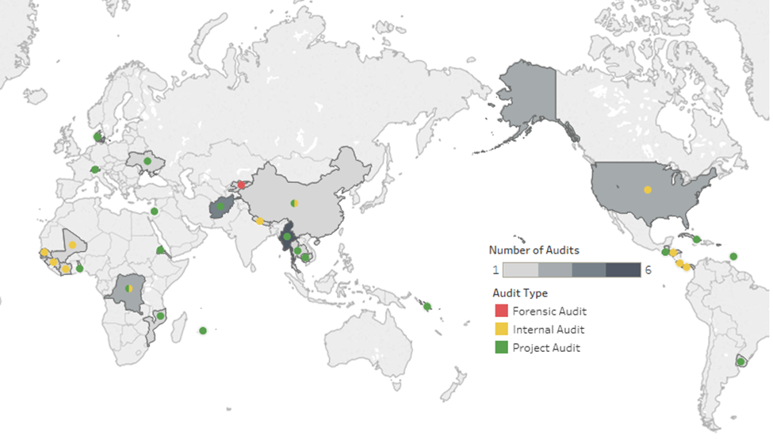

Highlights of 2017 audit activities
- As noted in table 1, IAIG issued 45 reports during 2017, compared with 37 in 2016 and 29 in 2015. The number of project audit reports is influenced by client requests and reporting requirements in project agreements. However, IAIG also made a concerted effort to increase its output in 2017.
- IAIG audits are delivered in two categories:
(a) Internal audits and reviews directly performed by IAIG (14 reports in 2017); and
(b) Project audits conducted under the supervision of IAIG by external auditing firms to fulfil project-reporting requirements (31 reports).
- The 45 reports issued in 2017 contain 315 audit recommendations. Of these, 200 pertain to internal audits (table 3) and 115 to project audits (table 6).
- Internal audits conducted directly by the Internal Audit and Investigations Group
Internal audit reports issued
- During 2017, 14 internal audit reports were issued by IAIG to the UNOPS Executive Director, as detailed in table 2.

Table 2. List of internal audit reports issued by
the Internal Audit and Investigations Group in 2017
Report title | Rating
Internal Audit of Senegal Operational Hub | Partially satisfactory – major improvement needed
Internal Audit of Peace and Security Cluster, Cote d'Ivoire | Partially satisfactory – some Improvement needed
Internal Audit Report of Panama Operational Hub | Panama Operational Hub: Partially satisfactory (some improvement needed)  Panama Project Centre: Partially satisfactory (major improvement needed)  Honduras Project Centre: Partially satisfactory (some improvement needed)  Costa Rica Project Centre: Unsatisfactory (ineffective)
Internal Audit Report of Nepal Operations Centre | Partially satisfactory – some improvement needed
Internal Audit Report of Small Grants Cluster | Partially satisfactory – major improvement needed
Internal Audit Report of China Project Centre | Partially satisfactory – some improvement needed
Internal Audit of Peace and Security Cluster, Mali | Partially satisfactory – major improvement needed
Internal Audit of Democratic Republic of Congo Operational Hub | Unsatisfactory
Review of Global Shared Service Centre | N/A
UNOPS Peace and Security Cluster Project Cooperation Agreement Modality Review | N/A
Vulnerability Assessment – UNOPS Critical Applications and Infrastructure | N/A
Review of Peace and Security Cluster Procurement | N/A
Cyber Security Assessment of UNOPS Procurement Systems | N/A
Follow-up on Implementation of Recommendations for Three Information and Communications Technology Assessments (Cyber Security, OneUNOPS Enterprise resource Planning Fraud Risk and Cyber Vulnerability) | N/A
Analysis of internal audit recommendations issued in 2017
- The number of internal audit recommendations issued decreased from 207 in 2016 to 200 in 2017, and the average number of recommendations per audit report decreased from 21 in 2016 to 14 in 2017. IAIG continued its commitment to the advice given by the Audit and Advisory Committee to focus on the more significant risks and systemic issues. As such, the number of internal audit recommendations per audit report decreased significantly in 2017.
- During the year, a further 19 recommendations were raised as a result of investigations. One of these recommendations was closed during the year. A further 21 were closed from previous years.
Level of importance of audit recommendations related to IAIG audits
- Of the 200 recommendations issued, 100 were considered to be of high importance and 100 of medium importance, as shown in table 3. Low priority recommendations are addressed during the field work stage of the audit.

Table 3. Categorization of audit recommendations by level of importance
Level of importance | Number of recommendations |  |  | Percentage of total
 | 2015 | 2016 | 2017 | 2015 | 2016 | 2017
High | 44 | 95 | 100 | 44 | 46 | 50
Medium | 57 | 112 | 100 | 56 | 54 | 50
Total | 101 | 207 | 200 | 100 | 100 | 100
Frequency of occurrence of audit recommendations by functional area
- The frequency of audit recommendations by functional area is displayed in figure 2. Most recommendations pertained to procurement (34 per cent), project management (21 per cent) and finance (12 per cent), followed by general administration (11 per cent), information technology (11 per cent), human resources (9 per cent) and legal (2 per cent). This distribution by functional area was driven by the audit scope as identified in the risk assessment for each engagement.
Figure 2. Internal audit recommendations by functional area
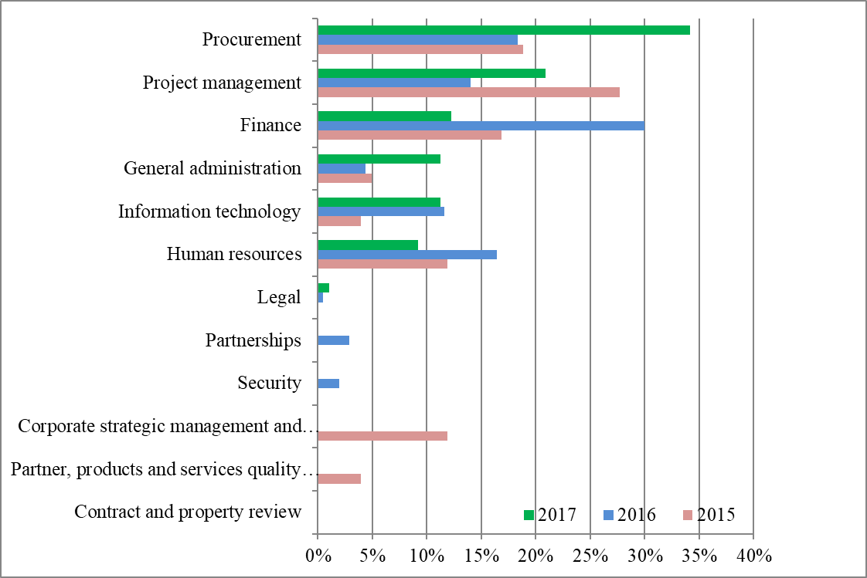
Key areas of improvement identified in 2017 internal audit reports
- Supplementing figure 2, figure 3 shows the number of recommendations by objective type. Recommendations on operational issues (37 per cent) were the most common, followed by those addressing strategic issues (33 per cent), compliance issues (29 per cent) and reporting issues (1 per cent). Key areas for improvement can be found in annex 6 of this report.

Figure 3. Recommendations issued in 2017 by objective
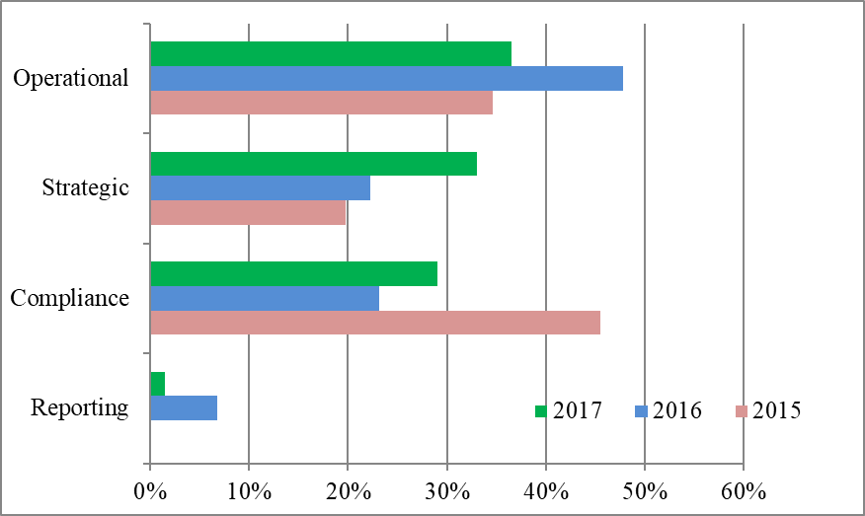
- Projects audits
Single audit principle
- IAIG upholds the United Nations “single audit principle” as detailed in the UNOPS report on internal audit and oversight in 2007 (DP/2008/21).
- IAIG provides technical support to project managers in meeting their projects’ audit requirements. For that purpose, the group engages pre-qualified third-party professional auditing firms to conduct these audits. The firms adhere to terms of references approved by IAIG and the audit reports they prepare undergo IAIG quality assurance before they are issued.
- All project audit reports issued in 2017 were provided by one firm with which IAIG has a long-term agreement. This arrangement provides cost efficiencies, consistency in reporting, improved timelines and a simplified process for conducting project audits.
Internal audit reports issued for projects
- During the year ended 31 December 2017, 31 audit reports relating to specific projects were issued by IAIG and submitted to the UNOPS Executive Director or Regional Director, depending on the project requirements.
- As shown in table 4, 24 of the 31 audit reports for projects issued in 2017 provided both an audit opinion on the financial statement of the project and a rating of the internal control environment. Six project audits provided an opinion on the financial statement only and a further one was a forensic audit. This was done in accordance with the requirements of the partner and primary stakeholder(s) concerned.
Table 4. Number of project audit reports issued, 2015-2017
 | 2015 | 2016 | 2017
Audit reports issued expressing an opinion on the financial statement and providing a rating of the internal control environment | 20 | 12 | 24
Audit reports issued expressing an opinion on the financial statement only | 2 | 11 | 6
Audit reports issued expressing an opinion on the internal control environment only | 0 | 2 | 0
Forensic audits | 0 | 2 | 1
Total | 22 | 27 | 31
- The proportion of project audits with a “satisfactory” internal control rating was 58 per cent (71 per cent in 2016). There were two project audits with an “unsatisfactory” rating for internal controls, compared with zero in 2016.
Table 5. Summary of project audit opinions and ratings
of internal controls for project audits, 2015-2017
Type of opinion  or rating | Number of audit reports |  |  | Percentage of total
 | 2015 | 2016 | 2017 | 2015 | 2016 | 2017
Audit opinion on financial statement of project (when required)
Unqualified opinion | 22 | 23 | 27 | 100 | 100 | 90
Qualified opinion | 0 | 0 | 3 | 0 | 0 | 10
Total | 22 | 23 | 30 | 100 | 100 | 100
Rating of overall level of internal control (where given)
Satisfactory | 15 | 10 | 14 | 75 | 71 | 58
Partially satisfactory (some improvement needed) | 0 | 0 | 3 | 25 | 29 | 13
Partially satisfactory (major improvement needed) | 0 | 0 | 0 | 0 | 0 | 0
Partially satisfactory (old rating system) | 5 | 4 | 5 | 0 | 0 | 21
Unsatisfactory | 0 | 0 | 2 | 0 | 0 | 8
Total | 20 | 14 | 24 | 100 | 100 | 100
Financial impact of project audit findings in 2017
- The Executive Board, in its decision 2010/22, requested that information on the financial impact of audit findings be incorporated in future reports. For 2017, the cumulative financial impact of project audit reports with a qualified opinion was $139,315 (zero in 2016). For internal control reports, the financial impact on audit observations was $171,247 ($52,973 in 2016).
Project audit recommendations issued in 2017
- The 31 project audit reports issued generated 115 audit recommendations, an average of 3.7 recommendations per report. This average has remained consistently within the range of 2.2 to 3.7 for the past three years. These 115 recommendations are analysed below by importance and frequency of occurrence in a functional area.
Level of importance of audit recommendations related to project audits
- As seen in table 6, the proportion of audit recommendations rated as being of “high importance” remained at 27 per cent.
Table 6. Categorization of project audit recommendations by level of importance
Level of importance | Number of recommendations |  |  | Percentage of total
 | 2015 | 2016 | 2017 | 2015 | 2016 | 2017
High | 0 | 16 | 31 | 0 | 27 | 27
Medium | 57 | 44 | 84 | 100 | 73 | 73
Low | 0 | 0 | 0 | 0 | 0 | 0
Total | 57 | 60 | 115 | 100 | 100 | 100

Frequency of occurrence of project audit recommendations by functional area
- The frequency of audit recommendations by functional area, displayed in figure 4, shows that in 2017 most recommendations pertained to project management (36 per cent), finance (29 per cent) and general administration (17 per cent). These areas were considered “high risk”, for which audit focus was directed in 2017. See annex 6 for key areas for improvement.
Figure 4. Project audit recommendations by functional area
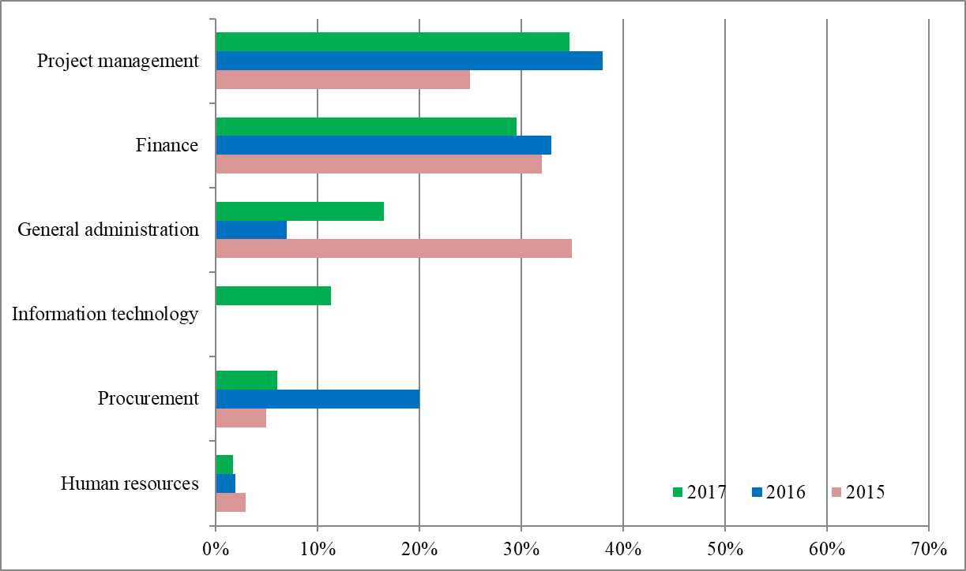
- Improvements to the UNOPS internal control system
- Management has taken immediate and commendable action to address the audit findings conveyed during 2017. During the year, UNOPS management and IAIG worked together to ensure the implementation of internal audit recommendations and to incorporate these results into performance data for various UNOPS departments. By using these performance data, management was able to resolve issues and identify additional risks, thereby safeguarding the effectiveness of the UNOPS internal control framework. The overall implementation rate of internal audit recommendations issued from 2008 to 2017 was 92 per cent. An additional 12 recommendations, which are more than 18 months old, remain open. This has been considered as part of the IAIG overall audit rating in annex 5.
- UNOPS operationalized its governance, risk and compliance framework, a process of simplifying its internal policy instruments and enhancing their alignment with business processes.
- UNOPS refined its global organizational structure. Its global portfolio of projects was organized under five geographical regions managing several country and multi-country offices. Now, all global projects are embedded within one structure, which enables improved management oversight, coordination and integration of in-country operations. The Finance Group assumed overall responsibility for enterprise risk management.
- UNOPS is committed to organizational excellence, accountability and transparency, and continuously seeks to improve its internal governance and operations. UNOPS also maintained the ISO 9001, ISO 14001 and OHSAS 18001 certifications, as part of its commitment to excellence and the implementation of best practice. OneUNOPS provides an advanced platform for customizing operational tools and guidance for personnel and management information to ensure speed and compliance.
- Advanced dashboards, many of which have been developed by IAIG as part of its data analytics programme, have improved internal transparency, managerial oversight and assurance that UNOPS operations are performed efficiently and in compliance with policy. They have also identified where improvements in policy, tools, competencies or resourcing are needed.
- Audit opinion
- Management is responsible for maintaining the adequacy and effectiveness of UNOPS governance, risk management and control. IAIG has the responsibility to independently assess the adequacy and effectiveness of the framework.
- The audit opinion is based on the audit reports issued by IAIG between 1 January and 31 December 2017 in conformance with the International Standards for the Professional Practice of Internal Auditing. The opinion is supplemented with a range of qualitative data as described in annex 5. The audit reports pertained to the following:
- audits of field offices;
- audits of cross-functional themes;
- audits of projects;
- IAIG continuous auditing and data analytics programme; and
- implementation status of audit recommendations as at the end of the calendar year.
- The majority of the audit reports issued in 2017 covered the 2016 and 2017 activities of UNOPS. A concise summary of the audit work that supports the opinion is included in parts A and B of this section of this report.
- In the opinion of IAIG, based on the scope of audit and investigations work undertaken, the adequacy and effectiveness of UNOPS governance, risk management and control were partially satisfactory (major improvement needed). This means that they were generally established and functioning but needed major improvement. The implementation ratio of audit recommendations as per 31 December 2017 is 92 per cent (down from 93 per cent in 2016), which implies that, in general, appropriate and timely action is taken, as and when improvements in governance, risk management and control are necessary. See annex 5 of this report for the audit opinion rationale.

UNOPS accountability framework
- In accordance with the UNOPS accountability framework and oversight policies, the IAIG Director reports to the Executive Board on the resources available and required for the implementation of the accountability framework.
- The pillars of the UNOPS accountability framework and oversight policies that are internal to the organization include: IAIG, the Audit and Advisory Committee, the Ethics Officer, the Office of the General Counsel Appointment and Selections Panel, the Appointment and Selections Board, the Headquarters Contracts and Property Committee, the balanced scorecard system and the implementation of UNOPS organizational directives and administrative instructions.
- The pillars of the UNOPS accountability framework and oversight policies that are external to the organization include: the Executive Board, the United Nations Board of Auditors, the Joint Inspection Unit, the Advisory Committee on Administrative and Budgetary Questions, and the Fifth Committee of the General Assembly.

Disclosure of internal audit reports
- IAIG complies with Executive Board decisions 2008/37 and 2012/18 and the procedures approved therein regarding disclosure of internal audit reports. IAIG experience with the public disclosure of audit reports continues to be positive, leading to enhanced transparency, accountability, timely action and quality assurance.
- Accordingly, IAIG has published, on the UNOPS public website, executive summaries of internal audit reports issued after 30 June 2012 and the complete internal audit reports issued after 1 December 2012. Furthermore, since November 2011 all functional and thematic audit reports, as well as the list of all audit reports issued since 2008, have been posted on the UNOPS public website, except when withheld for confidentiality reasons, on an exceptional basis.

Advisory services
- At the request of management, IAIG provides internal advisory services that cover a variety of issues relating to UNOPS internal controls, policies and organizational directives, business processes, proposed project agreements and other specific concerns. In accordance with Institute of Internal Auditors standards, IAIG acts only in an advisory capacity and does not participate in the implementation of any procedure.
- IAIG developed continuous auditing and data analytics techniques, providing periodic reports to management. Furthermore, the group advised management on the governance, risk and compliance framework and the enhancements of the enterprise resource planning system introduced in 2016 and continuous monitoring tests to be included in the configuration. IAIG assessed the vulnerability of UNOPS critical applications and infrastructure, along with the cyber security of UNOPS procurement systems, by conducting a comprehensive review of these functions. IAG also advised on a vendor database clean-up exercise. IAIG continued to conduct internal compliance evaluations, required to maintain UNOPS ISO 9001, ISO 14001 and OHSAS 18001 certifications.

Investigations
- IAIG is the sole entity in UNOPS responsible for conducting investigations into allegations of fraud, corruption, abuse of authority, workplace harassment, sexual exploitation, retaliation and other acts of misconduct.
- In 2017, IAIG handled a higher volume of investigations and closed 20 per cent more cases than in 2016. IAIG nonetheless completed these cases more quickly than in the previous years. The average time taken in 2017 to close cases was 27 per cent shorter than in 2016 (4.8 months compared to 6.6 months). At the end of 2017, only three cases had been opened for more than six months compared to six cases at the end of 2016.
- Further to IAIG focus on cases involving fraud and financial irregularities, UNOPS recovered $136,149 of misappropriated funds based on investigations that IAIG completed in 2017. IAIG also referred 34 employees and 25 vendors for disciplinary action or sanction.
- Complaint intake
- In 2017, IAIG received 111 complaints, a slight increase compared to 2016 (104 complaints). IAIG opened 59 cases based on these complaints, the same number as in 2016. The remainder (52) were found to be outside the IAIG mandate or could be more appropriately handled by a different unit.

Cases opened
- In addition to the 59 cases opened in 2017, a further 23 cases were carried over into 2017 (figure 5).
Figure 5. Number of cases opened, 2015-2017

- Of the 59 cases opened in 2017, 47 per cent were referred by management or personnel; 34 per cent via other means (external entities such as the medical insurance provider); 14 per cent through the UNOPS fraud or harassment hotlines, while the remaining 5 per cent originated from IAIG audits.
- The majority of cases opened in 2017 (43 cases or 73 per cent) involved some type of alleged fraud or financial irregularities (procurement fraud, entitlement fraud, theft, embezzlement or misuse of UNOPS resources). The remainder involved other types of misconduct: harassment and/or abuse of authority cases (six cases); external compliance (medical insurance fraud and violation of local laws) (four cases); conflicts of interest (three cases); and other types, such as misuse of UNOPS assets (three cases).
Figure 6. Types of cases opened in 2017

- Africa is the region from which IAIG opened the most cases in 2017 (22 cases or 37 per cent), followed by Asia and the Pacific (18 cases or 32 per cent), and Europe and the Commonwealth of Independent States (eight cases or 14 per cent). IAIG also opened three cases in the Arab States, three cases in North America, two cases in Latin America and the Caribbean, and two cases at headquarters.

Figure 7. Geographic distribution of cases opened in 2017

- Outcome of investigations
- When a complaint is received, IAIG conducts an initial review to determine whether the allegations fall within its mandate and jurisdiction. If it does, IAIG then conducts either a preliminary assessment or an investigation, depending on several factors, such as the sufficiency of the evidence or seriousness of allegations.
- If the allegations against a UNOPS personnel member are substantiated, IAIG refers the case to the Human Resources Legal Officer for disciplinary action in accordance with organizational directive 36. If the case involves a UNOPS vendor, the matter is referred to the Vendor Review Committee pursuant to organizational instruction PG/2017/02. Retaliation cases are referred to the Ethics Officer under organizational instruction Ethics/2018/01.
- In 2017, IAIG closed 67 cases, a 20 per cent increase from 2016 when it closed 56 cases. Table 7 shows the number of cases opened and closed in 2017.
Table 7. Investigation caseload in 2017
 |  | Number of cases | Per cent
Caseload in 2017  - Cases carried over from previous years |  | 23 | 28
- Cases received in 2017  Total |  | 59  82 | 72  100
Cases closed in 2017 |  | 67 | 82
Cases carried over to 2018 |  | 15 | 18

- IAIG investigated and completed its cases more quickly in 2017, due in part to the continued emphasis on triaging, which allowed IAIG to focus on the most serious cases. The average time for IAIG to complete a case in 2017 was 4.8 months compared to 6.6 months in 2016. As of 31 December 2017, IAIG had only three cases that had been open for more than six months and no case older than 12 months. In comparison, on 31 December 2016, IAIG had six cases that had been open for more than six months.
- Thirty-four of the 67 cases that IAIG closed in 2017 (51 per cent) were substantiated. In 31 cases (46 per cent), IAIG concluded that the allegations were not substantiated. The allegations in the remaining two cases were found to be outside the UNOPS mandate. IAIG thus referred one case to national authorities and the other to a different United Nations organization.
Substantiated cases
- The 34 substantiated cases (refer annex 4) involved 34 personnel members and 25 vendors. IAIG referred the personnel members to the Human Resources Legal Officer for disciplinary action and the vendors to the Vendor Sanctions Committee. The majority of the cases where misconduct was found involved fraud or financial irregularities (29 cases).
Table 8. Outcome of investigation cases in 2017
Outcome | Count
- Cases not substantiated  - After initial review or preliminary assessment  - After investigation  Subtotal | 21  10  31
- Cases outside UNOPS mandate | 2
- Cases substantiated | 34
Total | 67

Financial losses and recovery thereof
- The total financial loss that was substantiated in investigation cases by IAIG in 2017 amounted to $297,218, of which $268,507 was in fraud and $28,711 in misuse of assets. This amounts to less than 0.1 per cent of UNOPS total annual resources. IAIG referred this loss to management for recovery, and management recovered $136,149.
Management letters
- In 2017, IAIG issued 18 management letters to relevant business units to address weaknesses in internal controls, as identified by investigators. This was an increase from 2016 when IAIG had issued 10 such letters. They covered a wide range of topics, such as strengthening controls in the vendor registration process to prevent fraud through identity theft. IAIG uses the audit recommendations tracking tool to ensure that all recommendations given in these letters are properly addressed in a timely manner.
Action taken in cases of misconduct (2017)
- Based on 19 substantiated cases involving 34 personnel members that IAIG referred to the Human Resource Legal Officer in 2017:
- Five individuals were disciplined. Two were demoted and three had their contracts terminated.
- Eleven individuals separated from UNOPS before the investigation was completed and four separated after IAIG referred the case to the Human Resource Legal Officer. Letters were placed in their files indicating that they would have been charged with misconduct had they remained employed with the organization.
- The cases for 14 individuals were pending at the end of 2017.
- In two cases, IAIG found misconduct involving employees who had left UNOPS and had started working for another United Nations organization. In addition to placing a letter in their file, UNOPS referred the investigation reports to the other organization for appropriate action.
Action taken in cases of misconduct (prior cases)
- UNOPS also addressed matters against 12 individuals whose cases originated prior to 2017. Two individuals were terminated and one was demoted. The remaining nine individuals had left the organization. Hence, UNOPS placed notes in their files indicating that they would have been charged with misconduct had they remained employed with the organization.
Vendor sanctions
- IAIG referred 15 cases involving 25 vendors and 13 principals to the Vendor Review Committee in 2017. The Vendor Review Committee took action in seven of the 15 cases. As a result, UNOPS debarred two vendors for three years, three vendors and one principal for five years, four vendors for seven years and one vendor permanently. The committee also censured three other vendors. The other seven cases remained under review by the committee at the end of 2017.
- In addition, the Vendor Review Committee took actions in eight cases that originated prior to 2017. In these cases, UNOPS debarred nine vendors for three years, nine vendors and eight principals for five years, five vendors and five vendors for six years, and four vendors and one principal for seven years.
- To date, UNOPS has sanctioned 102 vendors and company principals based on IAIG findings. More details, including all UNOPS entries to the United Nations ineligibility list, are publicly available on the UNOPS website.
- The IAIG continuous auditing and data analytics program crosschecks sanctioned personnel and vendors against transactions as a prevention mechanism.
- Strengthening the investigative capacity
- In 2017, IAIG had four dedicated professionals, who were supported by an investigative assistant. It also recruited an additional person to assist with legal quality assurance of investigation reports. IAIG continued to rely upon consultants for additional support.
- IAIG used the services of a company with which it has a long-term agreement to perform its forensic computer services. IAIG also assessed eDiscovery tools available to conduct internally a portion of the forensic analysis needed for its investigations. In this regard, IAIG is in the process of procuring a tool that will increase the efficiency of investigators in their review of data.
- IAIG continues to focus its limited resources on serious cases and refers less serious matters to the appropriate offices. For instance, IAIG has continued to work closely with senior managers, who may undertake initial reviews of allegations on its behalf. IAIG has also worked with the People and Change Group on cases of harassment and abuse of authority. In this regard, the People and Change Group in 2017 created the Network of Peers to conduct preliminary assessments on such allegations. This network is composed of employees who received dedicated training on this topic. Their role is to advise the Director of the People and Change Group on appropriate actions and, where possible, to offer mediation to involved parties to diffuse any conflict.
- Fraud prevention
Training
- IAIG recognizes the high-risk environments in which UNOPS operates and is committed to strengthening preventative measures, particularly in the field of fraud. In 2013, UNOPS introduced a ‘standards of conduct’ workshop for its personnel. The objectives are to proactively raise the awareness of UNOPS employees on the importance of operating in line with the highest ethical standards, aligning the work UNOPS does with the UNOPS vision, mission and values, as well as training personnel to spot potential issues and know how to report them. IAIG also conducts a session on ethics and integrity in project management at every project management foundation course, which is held quarterly. In 2017, IAIG trained 101 personnel in these workshops.
- IAIG also worked with the Procurement Group to develop training on ethics and fraud prevention in procurement. The objective of this online course is to raise awareness on fraud risks in procurement and gives personnel the tools to identify potential red flags. It will be available to all personnel from January 2018 and is mandatory for all personnel with key roles in procurement.
- During 2017, IAIG also supported the Global Shared Services Centre in Bangkok to verify all separating personnel members during exit procedures, ensuring that there are no outstanding issues concerning them.
Integrity, ethics and anti-fraud survey
- The organization is committed to deterring, detecting and preventing fraud and other misconduct in the performance of its mission and in the conduct of its operations. Therefore, in collaboration with the Ethics Office, IAIG issued its sixth annual confidential survey regarding integrity, ethics and anti-fraud. The survey was conducted by an external consultant on behalf of IAIG. It was issued in three languages: English, French and Spanish. The United Nations Board of Auditors has recognized it as a good practice, and noted that UNOPS is the only United Nations organization that conducts this type of annual survey.
- In 2017, 61 per cent of UNOPS-supervised personnel participated in the survey, which is higher than the previous year’s response rate of 41 per cent. The survey provided valuable insight into areas of susceptibility to fraud, employees’ concerns and the effectiveness of deterrence programmes and mechanisms for addressing issues. The results of the survey will be incorporated into the planning of future activities, such as training and other preventative measures.

Summary of follow-up of internal audit recommendations
- Implementation of audit recommendations issued in 2017 and prior years
- In line with the International Professional Practices Framework for Internal Auditing, the IAIG annual workplan included follow-up and monitoring activities to ensure that management actions have been effectively implemented. IAIG also tracks recommendations resulting from investigations.
- Table 9 shows the outcome for all audit recommendations issued between 2008 and 2017. Of the audit recommendations issued in or prior to 2015, 99.7 per cent were implemented. The overall implementation rate of audit recommendations at 31 December 2017 was 92 per cent, which, although marginally lower than the 2016 rate of 93 per cent, demonstrates high management responsiveness. This is especially true given the increase in the number of recommendations issued in 2016 (267 recommendations) and 2017 (299 recommendations), compared to the 150 or so recommendations issued in 2015 and previous years.
- Recommendations unresolved for 18 months or more
- Owing to continuous efforts by management, the number of audit recommendations issued more than 18 months before 31 December 2017 (on or before 30 June 2016) that remained unresolved was 12 (3 per cent), of a total of 357 outstanding recommendations. This is to be compared with the figure for the end of 2016, when two (0.6 per cent) of 308 recommendations were outstanding. All recommendations reported as outstanding for more than 18 months in last year’s annual report have now been closed. Details are provided in annex 1.
Table 9. Status of implementation of audit recommendations issued before 31 December 2017
 | 2008-2015 | 2016 |  |  | 2017 |  |  | Total for 2008-2017
Number of audit recommendations | Total | IAIG audit | Project audit | Total | IAIG audit | Project audit | Total | Total
Implemented/closed | 3,935 | 159 | 53 | 212 | 12 | 12 | 24 | 4,171
as a percentage | 99.72% | 77% | 88% | 79% | 6% | 10% | 8% | 92%
Under implementation | 11 | 48 | 7 | 55 | 188 | 103 | 291 | 357
as a percentage | 0.28% | 23% | 12% | 21% | 94% | 90% | 92% | 8%
Total | 3,946 | 207 | 60 | 267 | 200 | 115 | 315 | 4,528

Operational issues
- Resources
- During 2017, the internal audit section consisted of one manager of the audit section (P5), two internal auditors (P4 and P3), three audit specialists (I-ICA 2), one data analytics associate (L-ICA 6) and one audit assistant (L-ICA 4). The Director of IAIG (D1) provides general direction and support to the section. IAIG is pleased to confirm its recruitment of a data analytics associate (L-ICA 5) in May 2017.
- The investigations section is composed of one manager (P5), one investigator (P3), three investigations specialists (two I-ICA 2 and one I-ICA 1) and one investigative assistant (L-ICA 5).
- The total budget for IAIG in 2018 is $3.036 million ($2.9 million in 2017), with $1.837 million ($1.565 million in 2017) allocated to audit activities and $1.199 million ($1.335 million in 2017) allocated to investigative activities. The increase in total budget relates to the addition of a Copenhagen-based auditor position (IICA 3).
- In 2016, the JIU found that IAIG has the lowest cost-per-audit-completed in the United Nations system. Since then, IAIG has increased its audit engagement output and number of personnel, while keeping overall costs constant. IAIG continues to make delivering better assurance for less cost a key priority in line with UNOPS goal of operational efficiency.
- The IAIG internal structure is supplemented by the engagement of third party professional firms and individual consultants. IAIG continued to retain a part-time editor for quality assurance of internal audit reports.
- Involvement with professional bodies and other groups
- IAIG continued its involvement with the Representatives of Internal Audit Services of the United Nations Organizations (UN-RIAS) and Representatives of the Internal Investigations Services of the United Nations Organizations (UN-RIS), coordinating internal audit and investigative activities among United Nations organizations, both in the quarterly virtual meetings as well as the annual face-to-face meeting.
- As in previous years, IAIG coordinated its workplan with the United Nations Board of Auditors. Audit recommendations, audit results, and the final audit reports, together with management responses, were continually shared with the United Nations Board of Auditors.
- IAIG continued in 2017 to work closely with the Joint Inspection Unit in order to strengthen internal oversight within UNOPS. IAIG participated in the networking group of the Heads of Internal Audit of International Organizations in Europe in April 2017 and participated in the annual Conference of International Investigators in September 2017.
- In October 2017, UNOPS/IAIG was the first United Nations organization to sign a memorandum of understanding with the Swedish International Development Cooperation Agency (SIDA). IAIG has signed cooperation agreements with 12 significant UNOPS partners. These memoranda of understanding help strengthen the confidence clients have in UNOPS. They also serve as a strong assurance-building tool for field colleagues who are negotiating for client funds.
- IAIG continued its law enforcement and government partnership with the Association of Certified Fraud Examiners (ACFE). UNOPS was the first United Nations organization to obtain this membership, which will help to raise UNOPS standard of practice and recognition among other United Nations organizations.
- In 2017, IAIG continued its formal relationship with the Institute of Internal Auditors, to whose international professional practices framework it adheres and of which all IAIG auditors are members. Auditors also met their continuing professional education requirements and maintained their respective audit and accounting designations and memberships.
- In 2018, IAIG will undertake a review of the UNOPS anti-bribery management system under ISO 37001. If successful, UNOPS would be the first United Nations organization to secure it.
- Strengthening the audit function
- IAIG works to continuously improve its professional practices, internal policies and procedures to remain relevant and current. IAIG has also expanded use of its online work planning and resource allocation tool (WrikeTM), which has significantly improved productivity and information flow.
- Throughout 2017, IAIG has undertaken new and continuous improvement initiatives, such as the use of data analytics, auditing for fraud and supporting the governance, risk and compliance framework initiative.
- Data analytics and continuous audit
- In late 2016, IAIG started using data analytics to proactively monitor risks and issues, and to prevent and detect possible fraudulent and anomalous transactions. This initiative addresses requests from the Executive Board and Audit Advisory Committee that IAIG boost proactive audit and investigation efforts.
- IAIG developed a dashboard and exception reports in UNOPS enterprise resource planning system (oneUNOPS) to enable continuous auditing, and to communicate anomalies to management so that corrective action can be taken. In 2017, IAIG issued three quarterly reports on its findings identified through the use of data analytics.
- The dashboards show the results of a range of algorithms that IAIG developed to identify issues such as duplicate payments, sanctioned vendors, over-spent projects and analysis of Benford’s law. Another test compares vendor transaction data to the Accuity database.
- On 1 May 2017, IAIG appointed a full-time data analytics person who is responsible for continuous auditing and fraud detection and prevention.
- While no fraud was identified, the data analytics person found the vendor management process is prone to serious risks and lapses in controls. These issues have been referred to management for action. IAIG identified the clean up of the oneUNOPS vendor database as a key priority and undertook a vendor clean-up review in the second quarter of 2017. The clean up has progressed well and the active vendor database has been reduced from over 61,000 active vendors to fewer than 45,000. Some of the key findings are as follows:
- Duplicate vendors: 2,884 profiles with duplicate emails, 781 profiles with duplicate phone numbers and 474 profiles with duplicate street addresses.
- Non-standard banking details: 2,105 bank accounts were found to be invalid (e.g. blank entries, zeroes, no swift code, no clearing code, or no IBAN), and still require further review before being actioned.
- Non-standard contact details of vendors: 8,914 vendor profiles were found not to have a street address, 8,862 vendor profiles did not have email addresses (this is a mandatory field for all vendor approvals), 4,206 vendor profiles did not have a telephone number associated with the vendor and 103 vendors had duplicate addresses (same vendor, same type of address and address).
- Personnel names and nationalities matching with other vendor types: 66 personnel were found whose names and nationalities matched with another vendor.
- Since integration of United Nations Global Marketplace (UNGM) with oneUNOPS is still not in place, UNOPS found itself transacting with three sanctioned vendors for $311,188 in 2017. Furthermore, six duplicate payments amounting to $30,144 were identified and referred to management for recovery.
- Sixty-four projects were not financially closed within 18 months of being operationally closed. The delay in project financial closure ranges from one to 69 months after operational closure.
- In 2018, IAIG will undergo an external assessment of its data analytics initiative. The aim is to enable IAIG to be proactive in fraud detection and prevention and to perform faster, cheaper and better audits in an innovative manner.
- Fraud topics
- IAIG, together with other United Nations organizations, has identified the need to review how fraud is approached as part of its internal audit assignments. This was echoed by the representatives of Internal Audit Services of the United Nations Organizations. In 2017, IAIG audits included a fraud risk focus in each internal audit engagement. In 2017, specific anti-fraud audit programmes with targeted fraud detection audit procedures were prepared, and covered the following focus areas: project management, procurement and contract management, human resource management, finance, asset management, travel and inventory. The data analytics work described above is also directed at fraud detection and prevention.
- As a result of this new approach, during 2017 internal audit engagements, six cases of presumptive fraud were referred to the IAIG Investigations Section for further scrutiny.
- Governance, risk management and compliance framework
- UNOPS has continued to progress in 2017 with its implementation of the governance, risk and compliance framework, the objective of which is to increase UNOPS capacity to “reliably achieve our objectives, while addressing uncertainty and acting with integrity", and to support required behavioural changes to better implement UNOPS activities.
- The framework introduces a “three lines of defence” model that helps ensure that the organizational structure best supports and facilitates compliance. IAIG, as the independent internal assurance provider, is the third line of defence.
- In 2017, IAIG supported the governance, risk and compliance framework through four key avenues to:
- confirm the implementation of recommendations for three information and communications assessments (cyber security, oneUNOPS enterprise resource planning fraud risk, and cyber vulnerability);
- improve the embedding of manual processes into oneUNOPS, the need for which became evident through the IAIG review of the Global Shared Service Centre in Bangkok in May 2017;
- build on the implementation of the IAIG continuous reporting tool in oneUNOPS, and act as an incubator for monitoring tests which can be handed over to second line of defence units (for example, the Finance Group and the headquarters Contracts and Property Committee); and
- continue to provide support and insight to the Legislative Framework Committee. The Director, IAIG, is an ex-officio member of the committee.
- As the Governance, Risk Management and Compliance framework takes traction, IAIG will explore how its risk assessment methodology can be informed by this framework.
- Key issues identified based on new IAIG initiatives
- During 2017, owing to robust audit efforts, including its enhanced audit programme, IAIG identified material audit issues that were referred to management for action. As of yet, no fraud has been identified. The issues included:
- Overspent projects in excess of $0.63 million, which may result in write-offs from operational reserves;
- Transfers between projects amounting to $587,854. Project funds were transferred from one project to another due to a lack of available funds in the latter project. Offices concerned did not receive prior approval for the transfer from the funding source;
- Late receipting led to an understatement of recorded project delivery for 2016 by $87,000 and an overstatement of the same amount in 2017. Late receipting resulted in an understatement of recorded project delivery for 2015 by $3.2 million (same amount overstated in 2016);
- Transactions amounting to $1,516,762 were approved by an official with a level 1 delegation of authority, when it should have been approved by an official with at least a level 2 delegation of authority;
- IAIG identified $3.9 million of purchase orders that were created after receipt of the goods or services.
- Recurrent errors in accounting records, such as the use of incorrect expense accounts amounting to $2.1 million;
- Payments amounting to $121,611 were not supported by adequate documentation, which meant it was not possible to link these costs to programme activities, or to check that they have been correctly incurred;
- IAIG identified cost savings of $72,000 that would have been realized if competition and value for money had been maximized for a certain procurement transaction. In addition, $9,265 was recovered from personnel for personal usage of official vehicles, after being flagged by IAIG; and
- Non-compliance with travel policy resulted in a financial loss of $32,538. This related to personnel undertaking business class travel without entitlement, and incorrect calculation of daily subsistence allowances.
- External quality assessment
- With a view to improving its internal audit function, IAIG internal audit activity underwent an external quality assessment in 2017, performed by PricewaterhouseCoopers. The Institute of Internal Auditors Standards require external assessments to be conducted once every five years. IAIG internal audit activity was assessed to “generally conform” to the standards, and to be in compliance with the institute’s code of ethics. This is the highest rating offered by the Institute of Internal Auditors Standards. The last such external assessment was conducted in September 2012. An external peer review of the investigations function was conducted in 2015.

Audit Advisory Committee
- During 2017, the Audit Advisory Committee continued to review the annual workplan, the quality assurance and improvement programme, the budget, regular progress reports, final audit reports and annual report of IAIG, and to provide advice on increasing the effectiveness of the internal audit and investigation functions. The Audit Advisory Committee annual report for 2017 is included in annex 3.

See the full Joint Inspection Unit report here.
Nil as requests for project audits are client-driven.
A detailed explanation of audit ratings can be found on the UNOPS external website.
Level of importance: High: action considered imperative to ensure that UNOPS is not exposed to high risks. Medium: action considered necessary to avoid exposure to significant risks. Low: action considered desirable and should result in enhanced control or better value for money.
As per entity objectives in “Internal Control Integrated Framework” (2013), issued by the Committee of Sponsoring Organizations of the Treadway Commission.
In 2018, UNOPS will replace organizational directive 36 with operational instruction IAIG/2018/01 on investigations and measures relating to allegations against UNOPS personnel.
In the two cases involving misuse of assets, there was not clear, convincing evidence of intentional misconduct. These cases are therefore not reflected in annex 4 of this report. Nonetheless, IAIG referred these cases to management to recover the financial loss of $28,711.
The censures do not affect their eligibility to do business with UNOPS or the United Nations, but they would be considered an aggravating factor in any future proceeding. UNOPS Operational Instruction PG.2017.02 on Vendor Sanctions, Section 6.1.1.
I-ICA: International Individual Contractor Agreement.
L-ICA: Local International Contractor Agreement.
See the full Joint Inspection Unit report here.

